Class presentations: IHS (Intro. To Health Science)
This rubric will be used to grade your class presentations. These two (presentations and essay) are equivalent of a test. Begin working on your project now, and be prepared to present during the trimester. You will be informed at least one week before you will present.
Presentations: 1. Health Science Career 2. Disease and Disorder
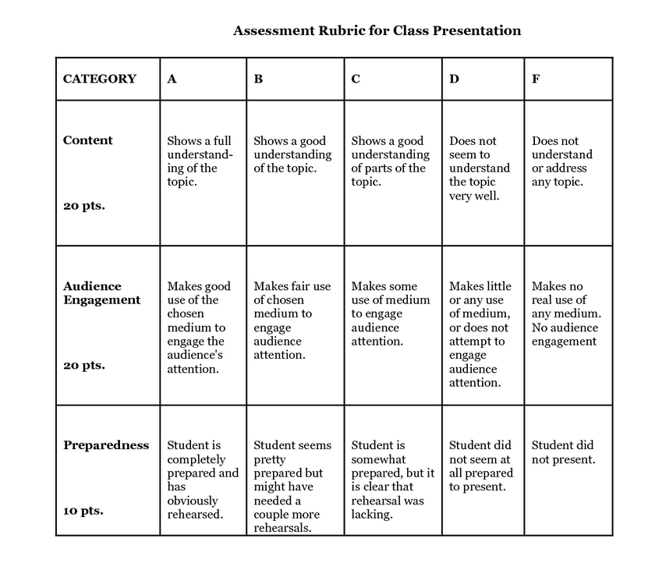
Written report (essay): A research paper will also need to be completed on the disease and disorder you selected. Below are the expectations for this essay. Your essay must include the following:
- A complete description of the disorder.
  - This includes when discovered, prevention measures, symptoms, causes, and current methods of treatments.
- Two pages, double spaced.
- Have at LEAST 3 citations. (Make sure they are listed at the end of your essay. If there is any plagiarism you will receive a zero. Use your own words)

